1. Write the leftist heap code insertion (language independent) and show by inserting 77, 22, 9, 68, 16, 34 , 13, 8 in that order .
2. Write a code to delete min in leftist heap and show the correctness of your code by deleting min element one by one.
3. In the following , two skew heaps are given, write a code to merge these two . show the correctness of your code by showing the merged skew heap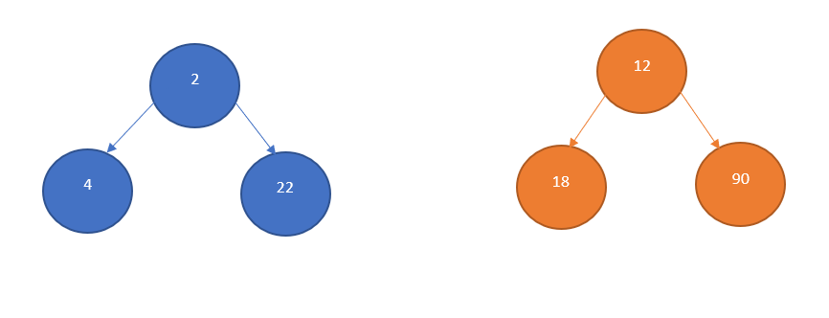
4. Write a code to implement dijikstra algorithm using binomial heap data structure .